BAHASA INGGRIS 2
REVIEW – QUIZ

- Look at the picture below and try to predict “what the text is about”. Write one sentence to answer this question.
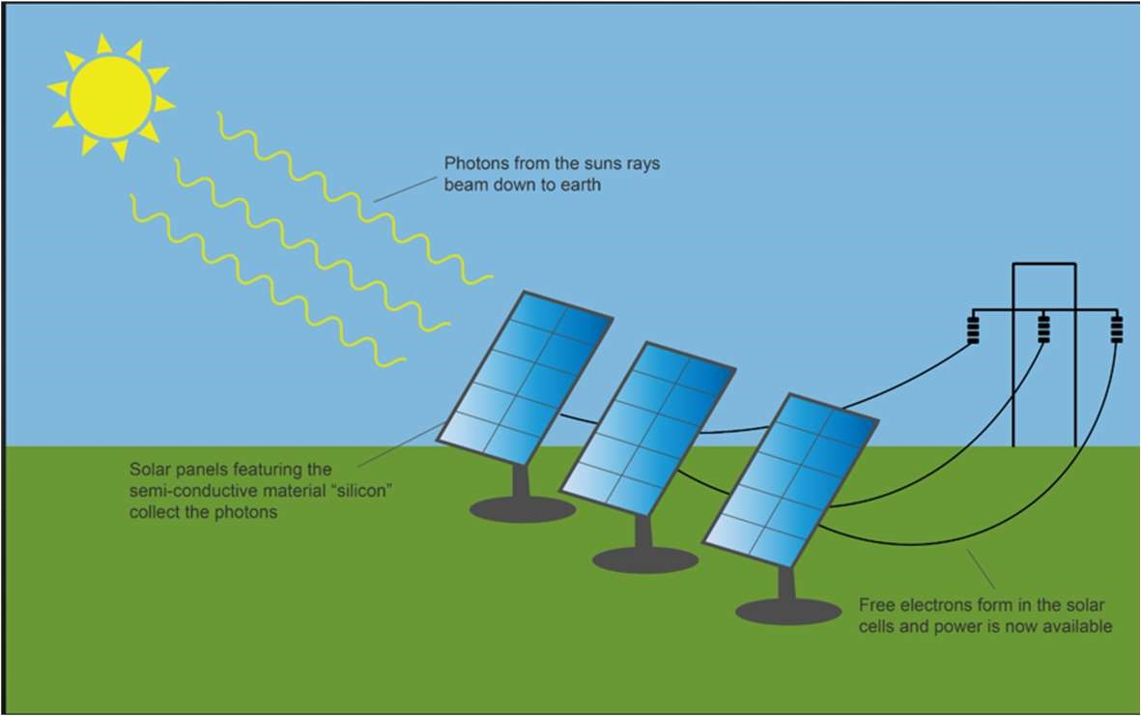

Your answer: The process of how solar cells convert solar energy to electrical energy

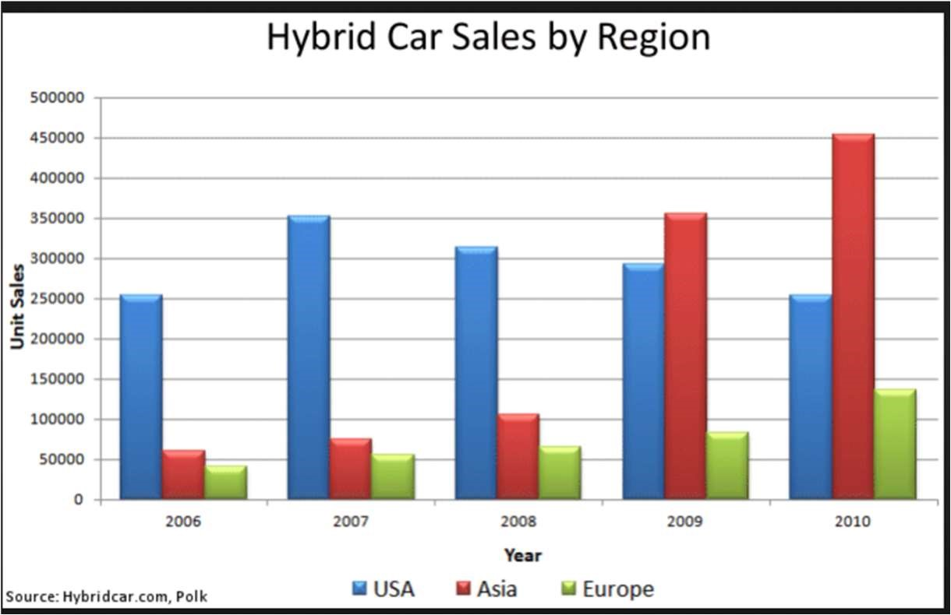
Your answer: The datas of hybrid car sales in USA, Asia, Europe. (Benar 2)

- Read this conversation and infer the answers to the questions below.
A: Excuse me. Would you mind turning down the music, please?
B: What's that?
A: I said, could you please turn the music down! My whole apartment is rattling!
B: Oh. Is that better?
A: A little better. It is after midnight.
B: Ah, come on. It's still early. It's my birthday, you know, so I asked a few friends over.
A: Well, that's very nice, but I've got to get up early tomorrow.
B: But it's Sunday tomorrow. What do you have to get up for so early?
A: That's none of your business. The rules say no noise after 11:00. So fi you're going to continue, I'll have to call the police.
B: Oh, all right. Don’t get so uptight about it all.

1 Where are these people?
Answer: people who living in the same place/Town/Apartment 2. Who are they?
Answer: Neighbors
- What are they talking about?
Answer: About the music that habe been so loud and disturb the neighbors
- Are they men or women? How can you tell
Answer: I think they are the women cuz they are so sensitive about the music that so loud and women usually asked their friend to come over on their birthday

- Read the following passage then answer the questions.
Trains connect the larger cities in Tunisia, but there are not many smaller train lines. To travel between the smaller cities and towns, most people take buses or zups.
(1)These kinds of transport are often cheaper than the buses or trains. (2)They leave as soon as (3)they have five people who want to go to the same place. (4)That might be a distant city, or a town nearby. The destination of the zup is written on a sign on the roof of the vehicle.
    - What does ‘These kinds of transport’ refer to?
Answer: zups.
    - What does ‘They’ refer to?
Answer: These kind of transport
    - What does ‘they’ refer to? Answer: Buses or zups (zups aja)
    - 4. What does ‘That’ refer to?
Answer: Five people who want to go to the same place ( the same place aja kalo ada five people berarti merujuk ke five people)

- Read three passages then write the topic, topic sentence, and supporting detail(s) in the space provided below each passage.
  - People have always been interested in bees. This interest may have begun with the honey bees make. In fact, archaeologists have found evidence that people have been eating honey for many thousands of years. In the more recent past, people were interested in the way bees made honey. They admired the way bees seemed to work so hard. Some languages even developed expressions about people working like bees. In English, for example, we talk about a “busy bee." Now scientists have a new reason to be interested in bees. They have discovered that bees are able to communicate with each other. Research has revealed some surprising facts about this, but there are still many mysteries.
Topic: bees have many things that always make people Interested to them.( Beres or human’s interests in beres)
Topic Sentences: People have always been interested in bees.
Supporting detail(s): people have been eating honey for many thousand years, people were interested in the way bees made honey, admired the way bees seemed to work so hard and now scientists have a new reason to be interested in bees, They have discovered that bees are able to communicate with each other. ( Benar 1)
( Hs make, language, scientists)
  - Communication is also possible among bees through their sense of smell. A group of bees, called a colony, uses smell to protect itself from other bees. This is possible because all the bees in a colony have a common smell. This smell acts like a chemical signal. It warns the group of bees when a bee from a different colony is near. This way, bees from outside cannot enter and disturb a hive (the bee colony's home). If an outsider does try to enter, the bees of that colony will smell it and attack it.
Topic: bees using smell to communication, protect, warns among the bees.
Topic Sentence: Communication is also possible among bees through their sense of smell.
Supporting detail(s): , uses smell to protect itself from other bees, all the bees in a colony have a common smell, smell acts like a chemical signal.
( yang bener Cuma A group of bees, calles a colony uses smell to protect itself from other bees)
(2)

  - If you ever get a blow-out while you are driving, you should know what to do. A blow-out is a sudden flat tire. It can be a very frightening experience, especially if you are traveling at high speed. If your car gets a blow-out, the first thing to do is to hold very tightly to the steering wheel. You can easily lose control of the car fi you do not have a good hold on the steering wheel. The next step is to get off the road. You must not try to stop or turn too quickly, however. After you check the traffic, you should move over to the side of the road and slow down gradually. Then you should turn on your flashing lights so other cars will see you. Topic: what to do when driving the car that blown-out.
Topic Sentence: If you ever get a blow-out while you are driving, you should know what to do.
Supporting detail(s): hold very tightly to the steering wheel, to get off the road, not try to stop or turn too quickly, move over to the side of the road and slow down gradually.

- Read the passage then write the topic and choose the best main idea for each paragraph.

Consequences of an Aging Population
1. The average age of the population of many countries is getting older. That means that businesses in those countries must adjust to older customers. In fact, many companies are working to respond to the special needs of the elderly. One example of this is the medical industry. New medicines and technologies are being developed especial- ly for the health problems of older people. Another business that offers services for the elderly is the tourist industry. Many travel agents offer special trips for groups of older people. And, finally, there are many different kinds of products made for the elderly. These include everything from shoes and shampoos to magazines and furniture.

Topic: ( business/ how business respond to the special needs of the derly)
Underline the topic sentence. Then circle the letter in front of the best statement of the author's main idea.
- The medical industry is developing new medicines for the elderly.
- New products and services are being developed by many companies.
- Many companies are developing products and services for the increasing elderly population.
Ts: in fact, many companies... (benar 1)
2. In industrialized countries today, many elderly people suffer from depression. The main cause of this is loneliness. In the past, older people usually lived with other members of the family. They usually had some responsibilities around the home. For example, older women could help take care of the children or prepare meals. Older men could help their sons at work or around the house. These days, married children often prefer to live on their own, sometimes far away from their parents. Thus, older people may be cut off from family ties. They may feel cut off from the world around them. Life has changed so much so quickly that older people sometimes feel that they do not belong any more.

Topic:
Underline the topic sentence. Then circle the letter in front of the best statement of the author's main idea.
- The elderly people in industrialized countries are often depressed because of loneliness.
- Older people used to live with other family members and helped take care of the children.
- Some elderly people may feel the world has changed too quickly for them
Ts: the mInd cause of this is loneliness
(1)

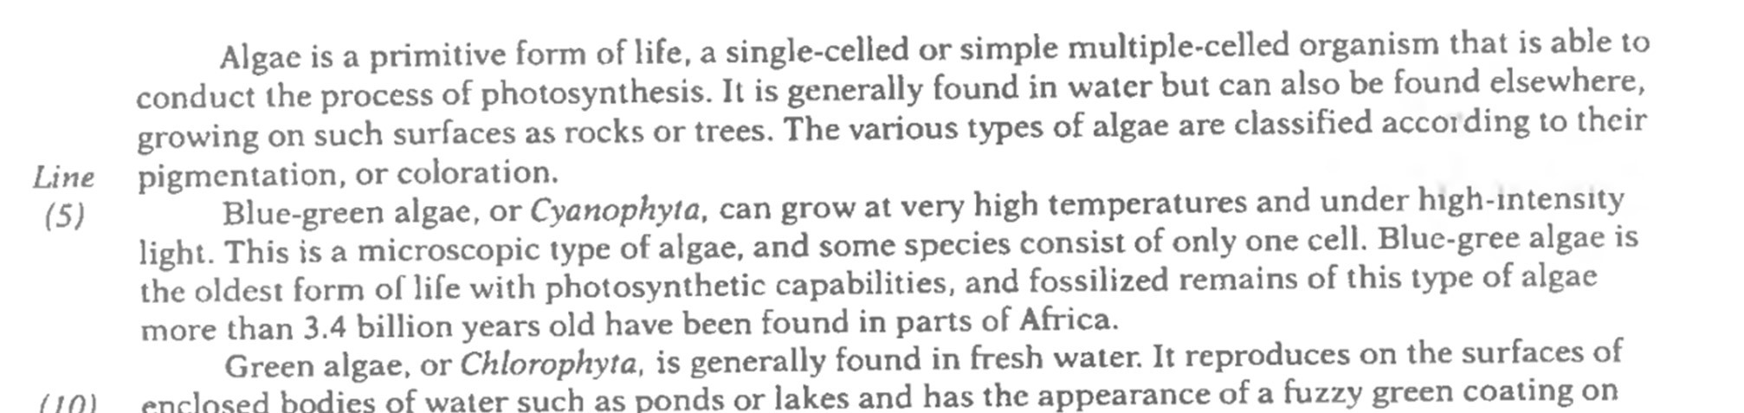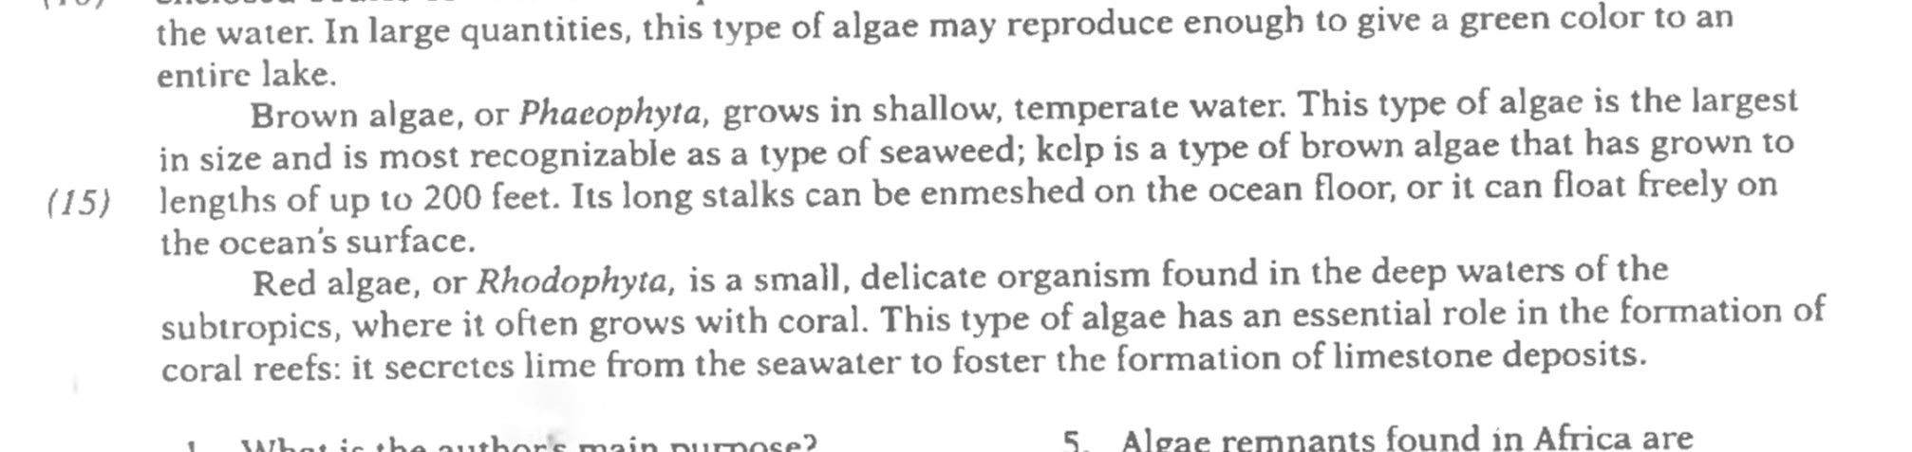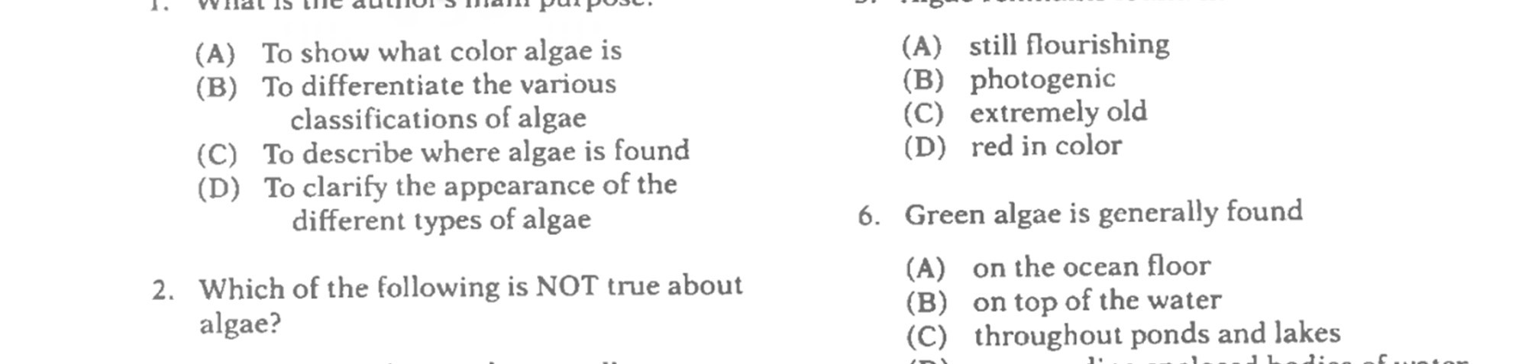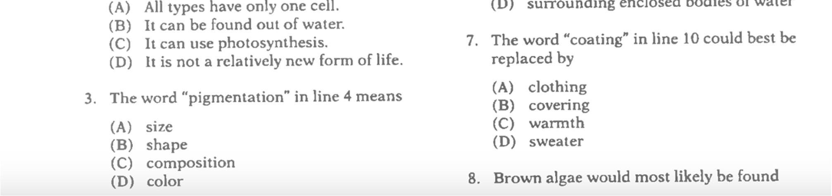

F.

Read the passage then answer the questions.

B:30